LOK JAGRUTI KENDRA UNIVERSITY
M.Sc. Cybersecurity Semester III
Class Test
Subject Code:340110313 Date: 26/10/2026
Subject Name: Cyber Security Fundamentals & Network Security
Duration: 01:00 Hour Total Marks: 10

NOTE: All the Practical’s are compulsory
- Mention Set number & Enrollment number in the answer sheet (If not written or wrong set number is written then answer sheet will not be evaluated and marked zero.)
- Also, only if the answers are correct then and then marks will be given
- Make sure no other documents apart from the necessary documents (which require during exam) for the exam should be open (If open then liable for the UFM)
- For the Viva, if student can’t answer the question, then 0 marks will be given by the invigilator/ viva taker.
- During exam, if student finds doing any copy paste from any document or taking help from the online medium then answer won’t be accepted and will get 0 marks for the whole exam (UFM)
- Students can write down the analysis according to the steps, make sure steps include technical words only (If not then marks will be given accordingly).
- Also Screen Shot should be appropriate as per the steps and important things must be highlighted in the Screenshot with the Timestamps (If not then marks will be given accordingly)
- Most Importantly, screenshots without proper visibility of timestamps will not be considered and the student can be liable to get 0 marks.
- If any students have just mentioned the Steps without appropriate Screenshots, then the question gets 0 marks.
- If the Browser history Screenshot before and after the exam is not there then marks will be deducted accordingly.
- Answer sheet will only be accepted in the google classroom submission (If students fail to submit on time due to any reason, they will get 0 marks)

ANSWER SHEET
Practical: 01

AIM: A Security analyst is asked to check an intentionally vulnerable Metasploitable 2 machine in an isolated lab. Using Nmap, perform a scan to identify open ports and running services, carry out service/version detection, and prepare a short inventory of any five discovered open ports with their associated services.

Procedure

Step 1: Metasploitable IP and Connectivity

Start metasploitable and login by default username and password: msfadmin
Then for view ip address of mesplotable run command: ifconfig
Then oprn kali linux and open new terminal then check metasplotable is reachable or not by ping command: ping -c 4 192.168.184.130

PoC (Screenshot with Steps):
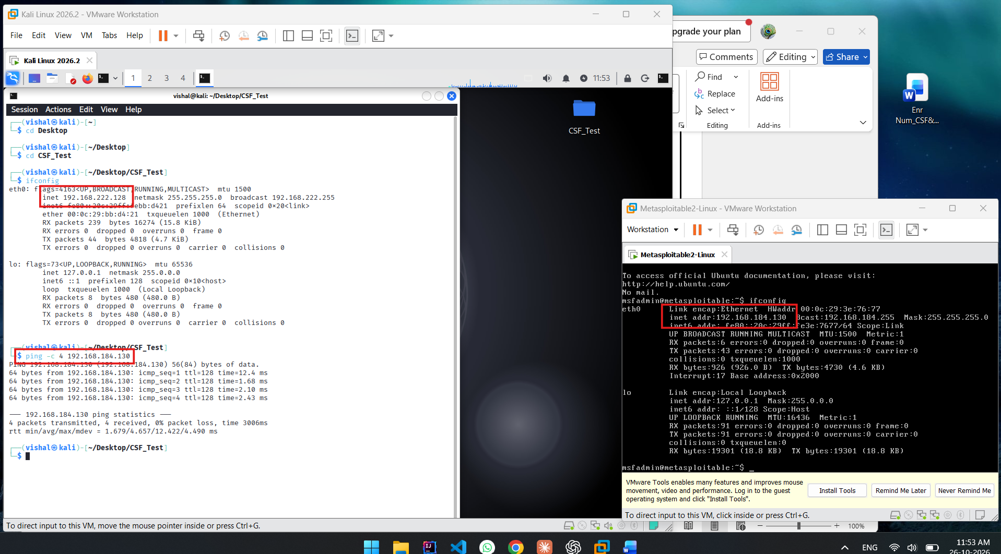

POC Explanation:
Here in screenshot showing metasplotable is running on ip address 192.168.184.130 and kali linux is running on ip address 192.168.222.128.
Ping -c 4 192.168.184.130 is showing 0% loss means metasploitable is on and reachable.

Step 2: Basic Port Scanning by Nmap

For basic scan run command: nmap 192.168.184.130
This is showing which ports are open.

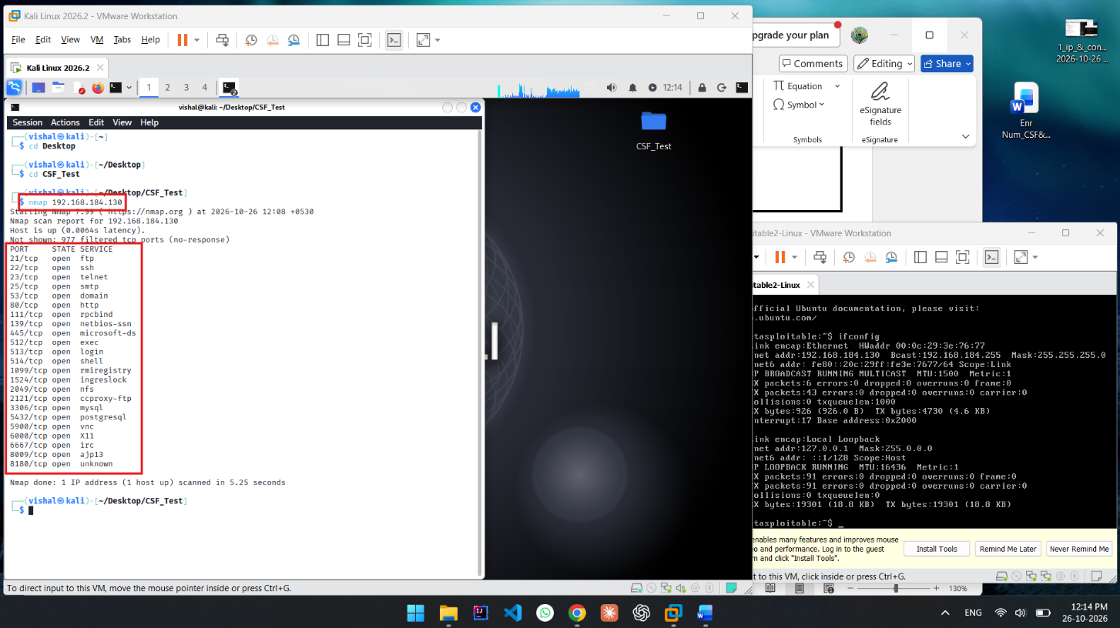

POC Explanation:
This is screenshot showing basic nmap scanning by command: nmap 192.168.184.130
Result is showing all open ports
Here we see tcp port that open,

Step 3: Service and Version Detection

For finding which service running on which version run this command: nmap -sV 192.168.184.130

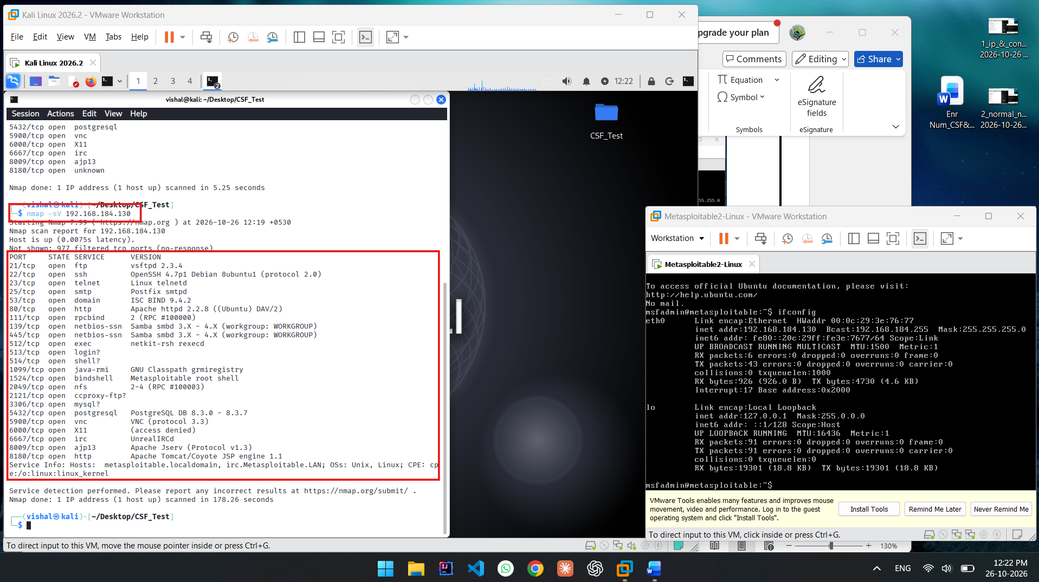

Step 4: Operating System Detection

Run: nmap -O 192.168.184.129
-O = Operating System detection.

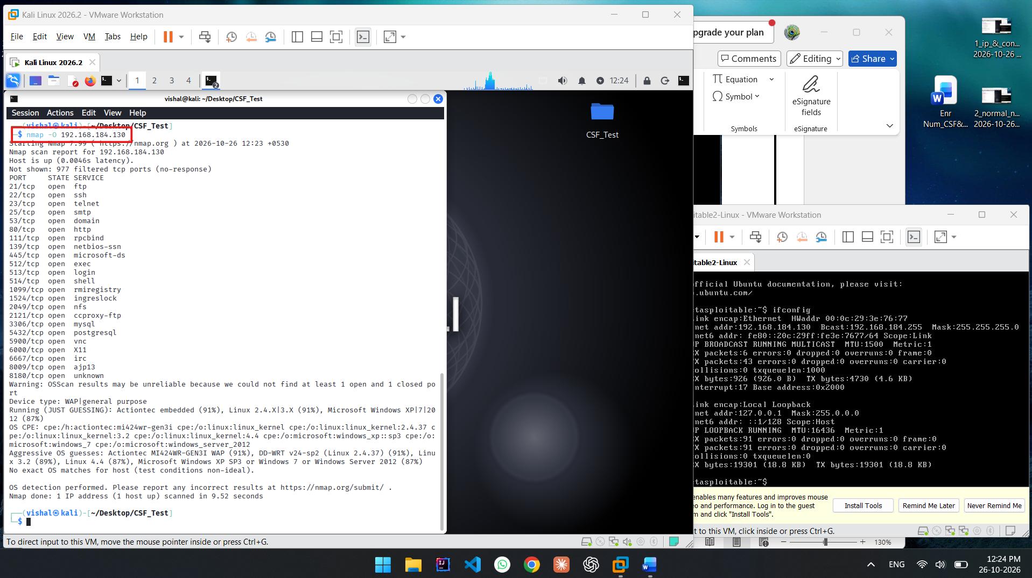

Step 5: TCP SYN Scan
Command used: nmap -sS 192.168.184.129

The -sS option performs a TCP SYN scan. It checks whether TCP ports are open by sending SYN packets and analyzing the responses.

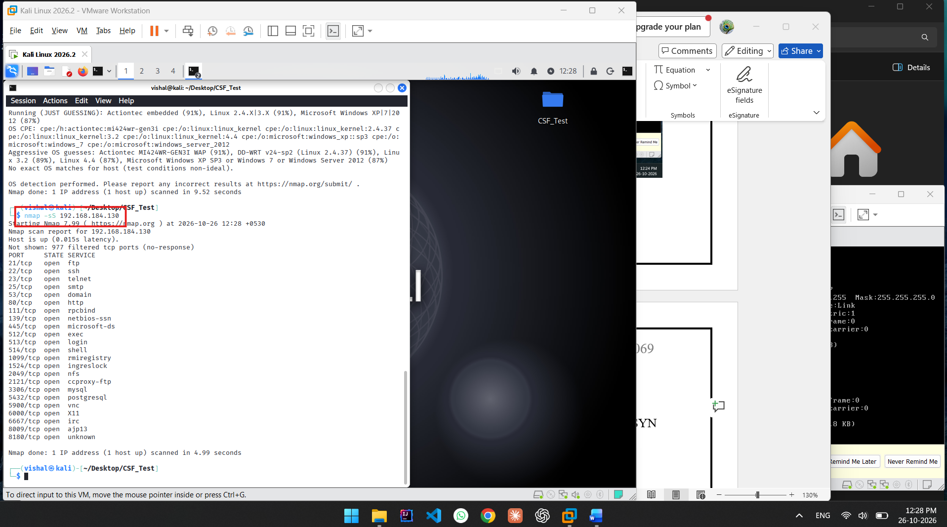

Conclusion
Nmap scanning and service detection practical was successfully performed on the Metasploitable 2 system. Various Nmap techniques were applied to discover open TCP ports, identify active services and their versions, determine the target operating system, and conduct TCP SYN and TCP Connect scans.
Practical: 02

AIM:

PoC (Screenshot with Steps):

Analysis:

Conclusion

*** END OF ANSWERSHEET ***

